Strategy for OMERO updates #3670 - Existing Software review on updates

- Flash updates.

I was viewing the updates through the adobe site it uses the global notification settings panel to either turn on/off the notification of updates. When the updates are turned on the option to check for updates every 7, 14, 30, or 60 days.

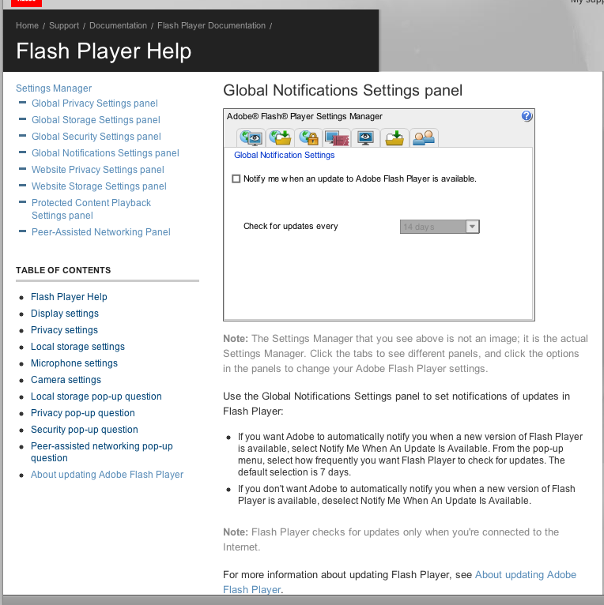

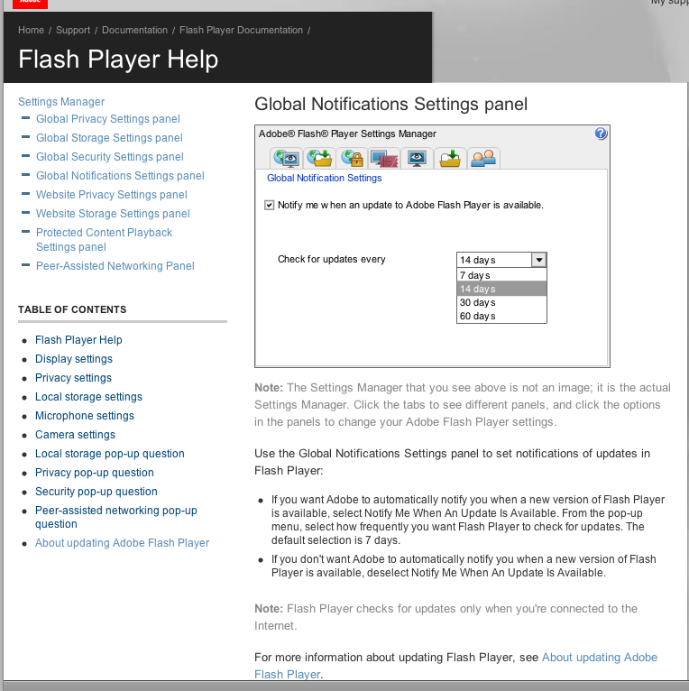

ImageJ via web start. http://rsbweb.nih.gov/ij/applets.html

Due to several issues with running web start via the imageJ site the web start a prototype workflow was viewed on Josh’s machine.

- 1) Launch of web start either through asking for update or done automatically (Pointing at the OMERO server)

- 2) The web start would be started/opened

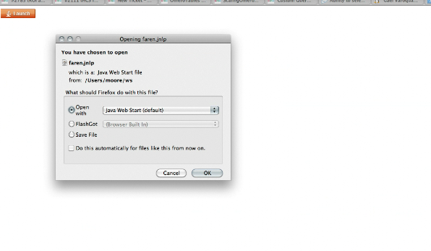

3) The window and icon would be changed accordingly to handle the OMERO information.

- The web start update could be problematic in that the user may have pre-defined settings on the java download. This would require sufficient instructions/documentation to ensure that this could be prevented.

Cailbre e-book management - http://calibre-ebook.com/

Note: It was problematic to view further software updates as my laptop was restricted to an older version and so checking for the new updates was restricted. The alternative windows install that I tried was terrible and I could simply not get it working. But if extra screenshots are required I can try further to get the windows version working. Because of this the update information is limited.

The two central points for the updates were just in the information presented

- The information panel used for the updated (Highlighted in blue) has a link to the website with the information on the new features that are available.
- There is an initial notification for the update in right corner of central panel (Highlighted in red). When clicked on this takes you to the download page for the software.

Eclipse - http://www.eclipse.org/ (osgi based)

1) On starting eclipse

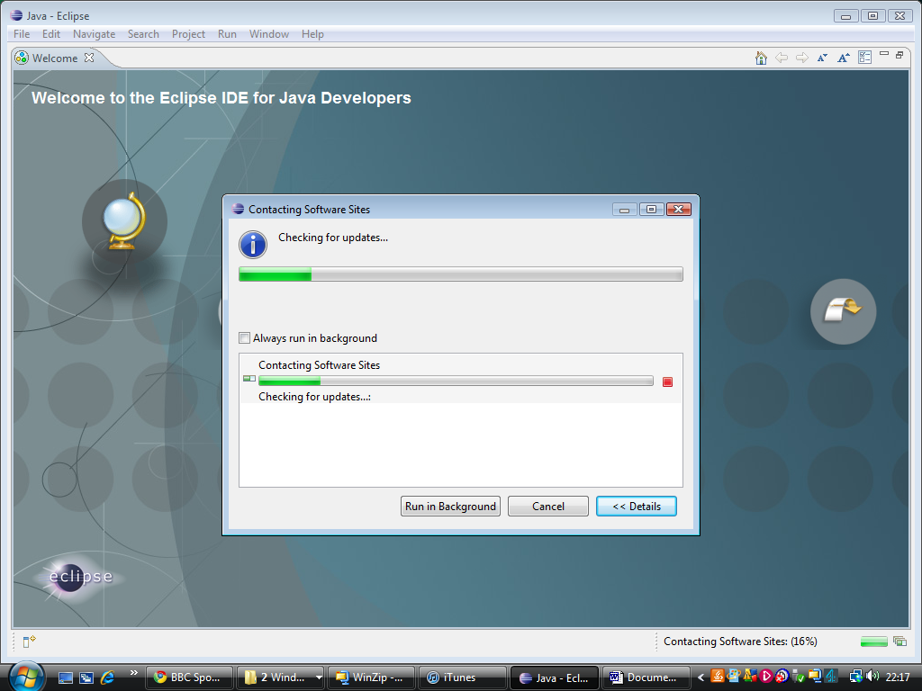

2) Eclipse provides the option to run updates in the background.
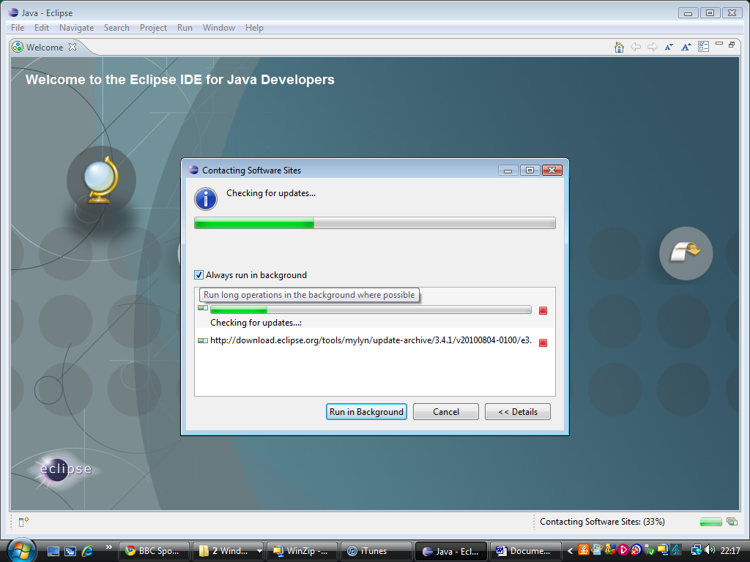

3) Update provides the ability to show further details and cancel particular options of the update.
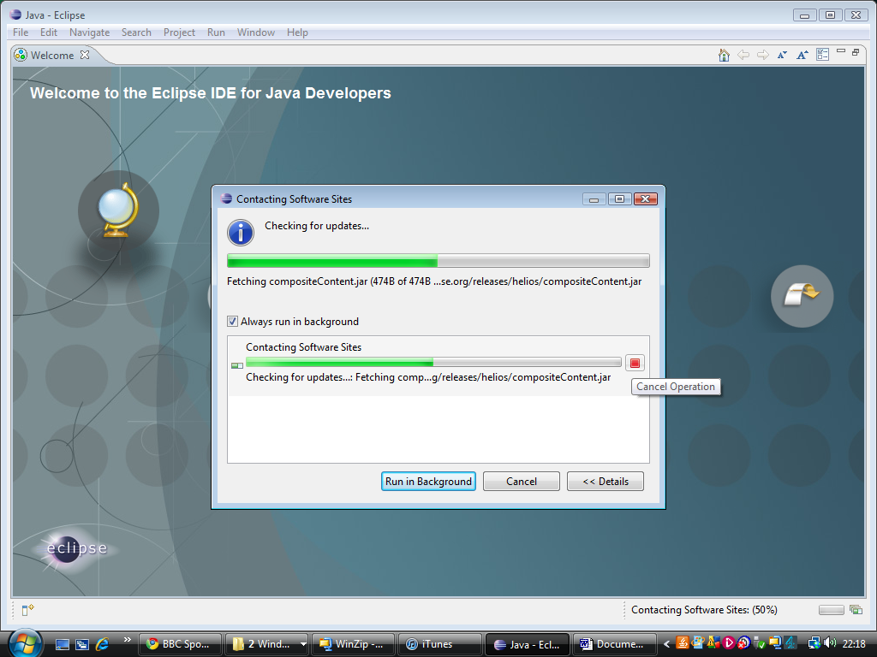

- Note
In speaking with Ola and Will’s experience of working with Eclipse they have not used or seen the eclipse update option. It was noted that the software does not have regular updates so judging the user experience might be difficult.

Vuze

This software was a bit problematic in that I have not had any proper software updates available. Because of this I have also considered the automated update process of checking for the download speed that the application does on starting. There was no difference between the process apart from a different start screen.

1) On starting vuze its run a check in the bottom corner
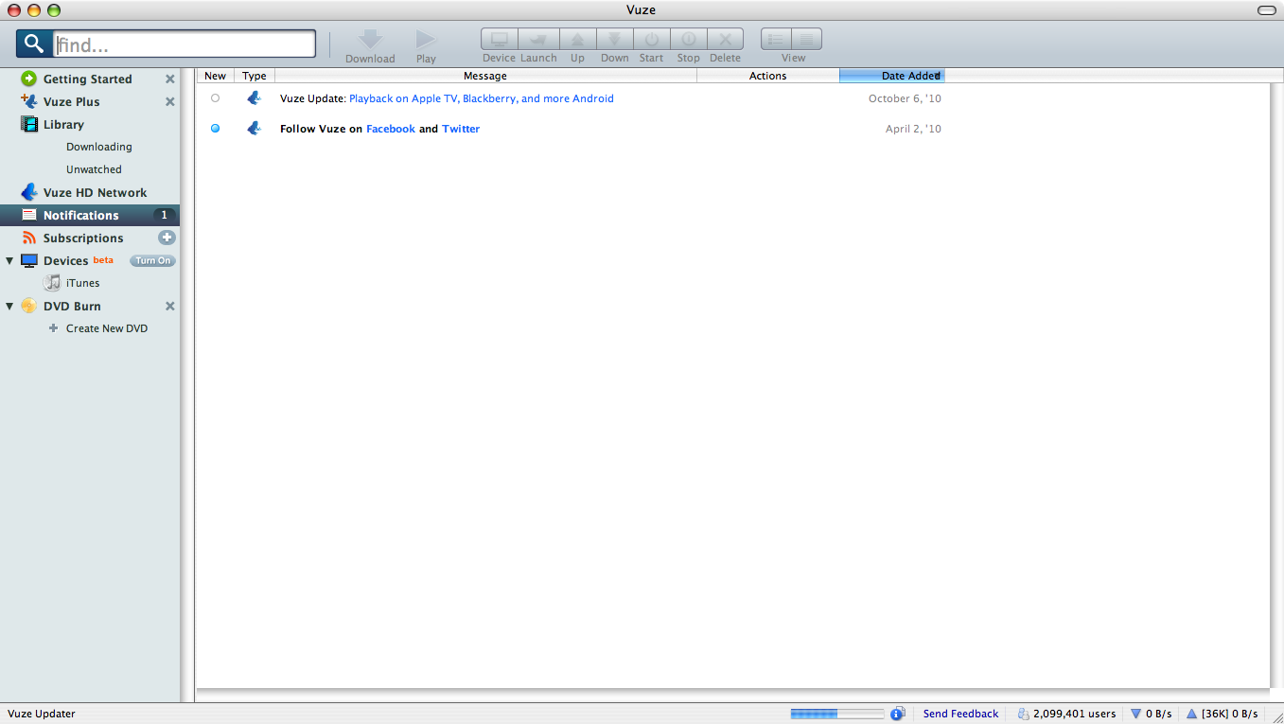

2) The following operation in progress box is available upon clicking on the information icon.

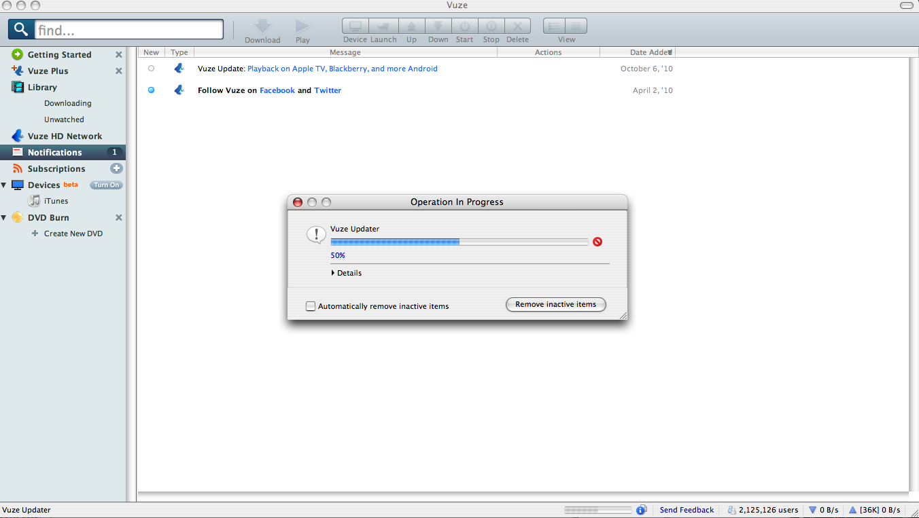

3) The details of the update can be revealed.

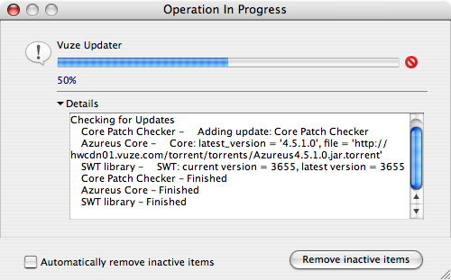

4) On completion this returns no new updates available. (I am not sure why it has congratulations?)

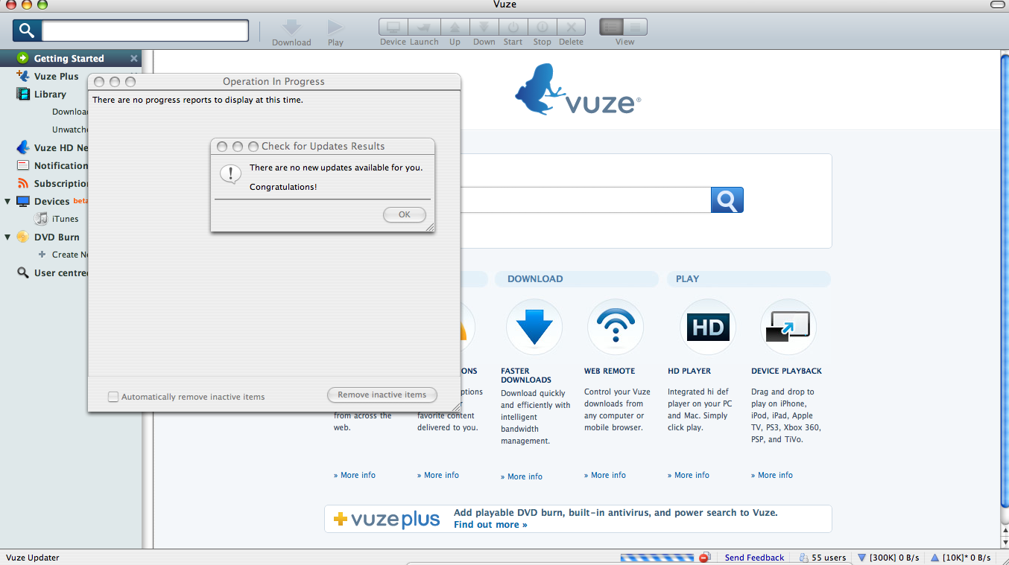

Vuze also provides the option to allow a user to check for updates themselves from the help menu.

